**Will Bushfires Get Worse in Australia?**

Bushfires are an always present part of Australia’s history, but with more recent events impacting larger areas of land, what does the future of bushfires look like? Are we in store for more of these natural disasters?

Using data from NASA’s Fire Information for Resource Management System (FIRMS), a set of satellites that collect infrared hotspots that indicate fires over a square kilometre, we are able to better document and understand the underlying causes of the large number of bushfires that pop up in Australia every year. With most history of bushfires poorly documented or focusing solely on populated areas, this recent 15 years of data collected allows for a more holistic analysis of our bushfire history and its possible causes.

**Climate Change is Real**

Bushfires usually occur in dry and hot seasons, allowing the perfect conditions for their ignition. With rising temperatures noted in the last century for Australia, these hots seasons could last longer. We haven’t seen a decline in overall precipitation, but monthly data shows more extreme minimum and maximum rainfall. Thus, some seasons may be extremely wet or dry like we’ve never seen before.

[Insert line graphs of temperature and precipitation over the last 100 years to show these trends]

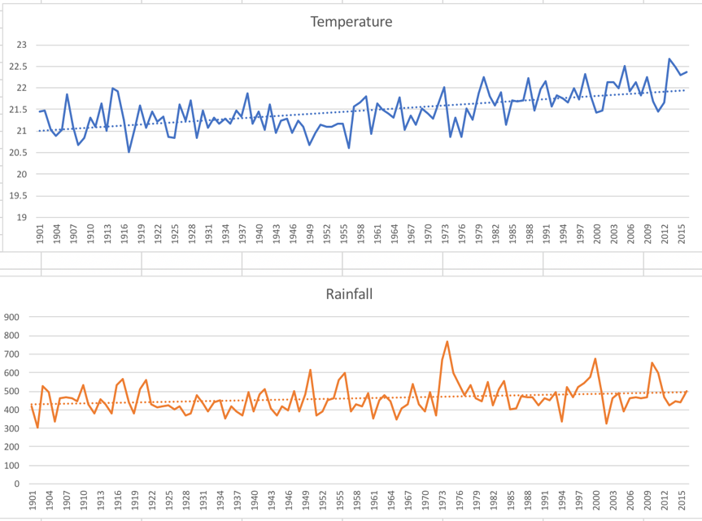

**Bushfire History**

15 years of this hotspot data has been paired with climate data from the World Bank Group. Given an average of 20,000 hotspots per month for the 21st century, explore the recent years activity along with notable events in recent history. The percent change allows for a better understanding of how our climate is fluctuating during that month and possible conditions for these bushfires to thrive in.

[Interactive History Map Graph] https://perrindesign.github.io/bushfire-visualisation/

**See the Connections Yourself**

Below is a parallel coordinates graph with both the relevant climate conditions and hotspot activity. Select values on an axis to filter and see the relationships of both the overall bushfire seasons and climates effect on them. The axes can also be reordered by dragging them to the desired position.

[Parallel Coordinates Graph] https://perrindesign.github.io/bushfire-visualisation/

Through this graph, we can see that higher temperatures and lower precipitation lead to some of the highest hotspot activity. With both of these climate changes in our future, we are likely to see more bushfires popping up through Australia

**Bushfire Seasonality and Heatmap**

Although we can see trends in Australia overall, it is important to consider the seasonality of the fire seasons for different parts of Australia. Notable events like the Canberra bushfires in 2003 and the The Great Divide bushfires in Victoria in 2006 and 2007 can also be viewed, while other large bushfires appear that were never documented due to their lack of threat and isolation.

[Heatmap] https://perrindesign.github.io/bushfire-visualisation/

Sources & Resources